**Australian Property vs. S&P 500 (1990–2024): A Comparative Analysis**

Australian property and the S&P 500 (in AUD) represent two of the most popular investment options for wealth creation. This article compares their performance over the past three decades (1990–2024), analyzing returns, risks, and key drivers like interest rates, migration, and wage growth. Whether you're an investor, homeowner, or policy enthusiast, understanding these trends can inform better financial decisions. We’ll explore:

* Annual return trends and volatility
* Impact of interest rates and migration on property prices
* Divergence between wage and housing price growth
* Risk-reward trade-offs between Australian property and the S&P 500

**1. Housing Price Growth vs. Wage Growth (1990–2024)**

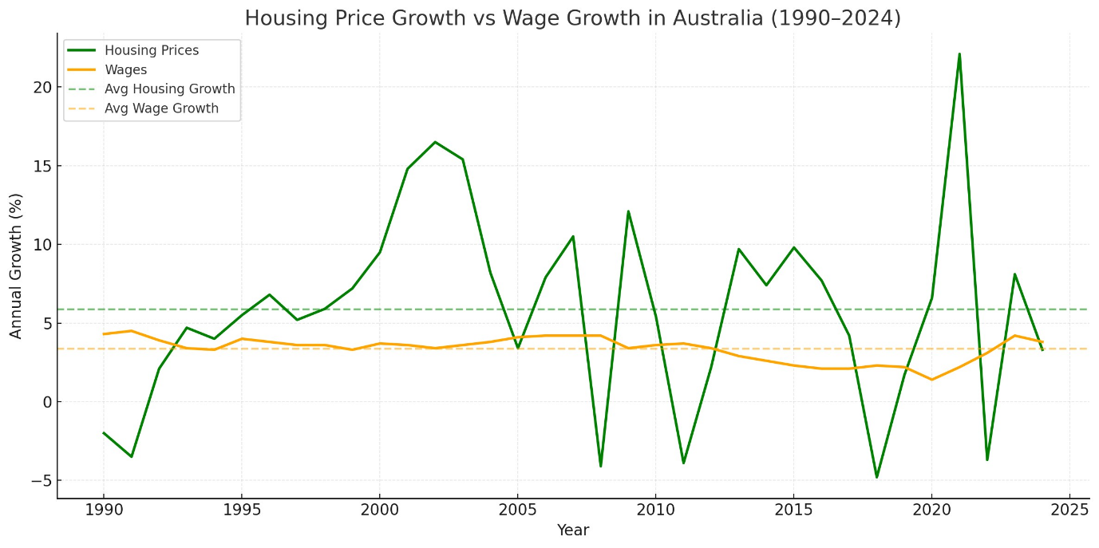

**Figure 1:** Annual Housing Price Growth vs. Wage Growth. *Sources: ABS, CoreLogic*.

Over the past three decades, Australian housing prices have significantly outpaced wage growth. House prices have averaged an annual growth rate of approximately 6%, while wages have grown at a modest 3% per year. However, housing prices exhibit much higher volatility, with sharp spikes during boom periods (e.g., early 2000s, post-COVID recovery) and occasional corrections.

But when looked at the **Indexed Growth from 1975–2025 with base of 100**

**Figure 2:** Indexed Median House Price vs. Wage Growth since 1975. *Source: ABS*.

**Taking a broader view from 1975, house prices have skyrocketed nearly 48-fold, while wages have only increased around 10-fold. This indexed comparison reinforces how housing has consistently outpaced income growth over nearly five decades. The chart below visualises this divergence and provides historical context for the affordability debate today.**

**Key Insight:** The growing gap between housing prices and wages has strained affordability, particularly for younger Australians...

**2. Interest Rates and Housing Price Growth (1975–2024)**

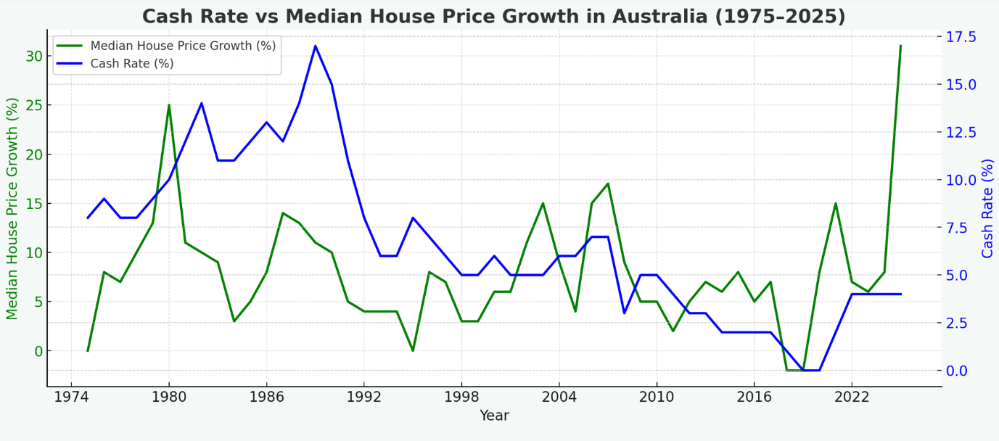

**Figure 3:** Interest Rates vs. Housing Price Growth. *Source: RBA*.

Low interest rates have been a critical driver of Australian property price growth. From 2000 to 2024, periods of declining RBA cash rates (e.g., post-GFC and post-COVID) coincided with surges in housing prices. Cheap credit increased borrowing capacity, enabling buyers to bid up prices without corresponding income growth.

**Key Insight:** While low rates have boosted affordability through higher borrowing power, they’ve also fueled price inflation, making it harder for first-time buyers to enter the market without significant debt. Rising rates since 2022 have started to moderate growth, but the long-term trend favors property.

**3. Net Migration and Housing Supply (2000–2024)**

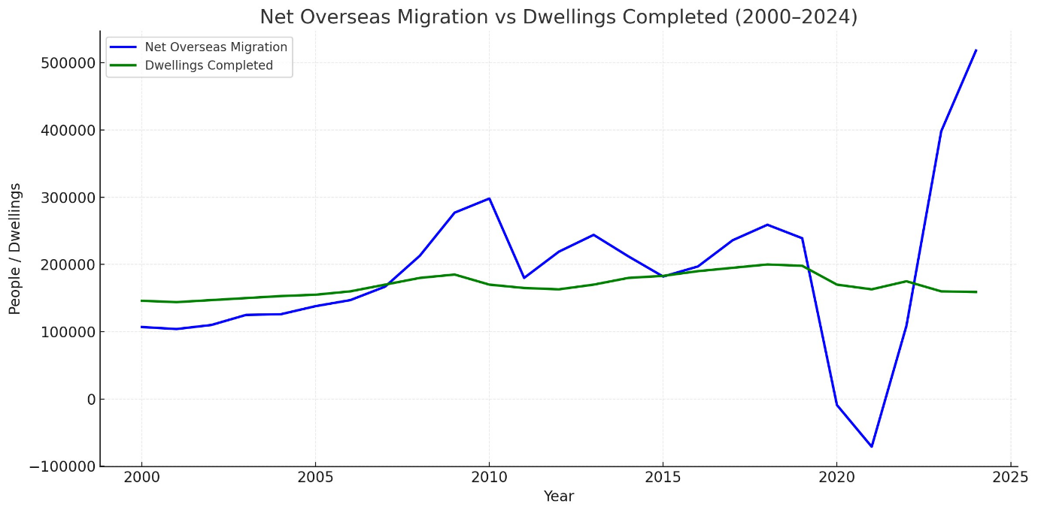

**Figure 4:** Net Migration vs. Dwellings Completed. *Sources: ABS, Department of Home Affairs*.

Australia’s population growth, driven by net migration, has consistently outpaced dwelling construction, creating a persistent supply-demand imbalance. Post-COVID immigration surges (2022–2024) have intensified this gap, particularly in major cities like Sydney and Melbourne, where demand for housing has supported elevated prices.

**Key Insight:** Migration-driven demand is a structural factor supporting property prices, but inadequate housing supply exacerbates affordability challenges. Policymakers face the challenge of balancing immigration with infrastructure and housing development.

**4. S&P 500 vs. Australian Property Returns (1975–2024)**

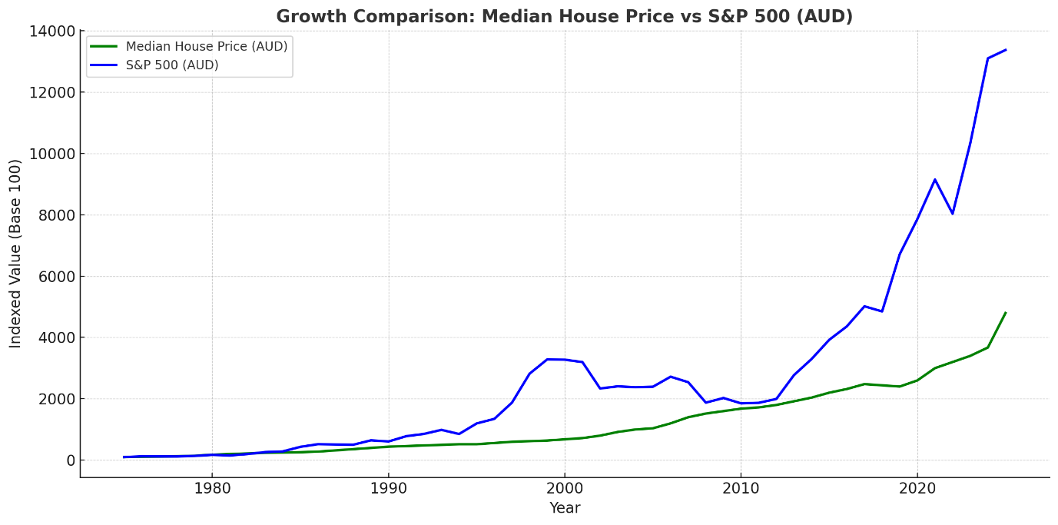 **Figure 5:** S&P 500 vs. Australian Property Returns (AUD-Adjusted). *Sources: Yahoo Finance, CoreLogic, RBA FX Rates*.

When adjusted to Australian dollars, the S&P 500 has delivered stronger total returns than Australian property over the 34-year period, averaging around 8–10% annually compared to property’s 6%. However, the S&P 500 comes with higher volatility, experiencing larger drawdowns during market crashes (e.g., 2008 GFC, 2020 COVID crash). Property, by contrast, has shown more stability but with lower liquidity and higher transaction costs.

**Key Insight:** The S&P 500 offers higher returns for investors comfortable with market swings, while Australian property provides steadier growth and tangible asset ownership, appealing to risk-averse investors. Currency fluctuations also impact S&P 500 returns for Australian investors, adding another layer of risk.

* **Returns:** S&P 500 outperforms property in total returns but with greater volatility.
* **Risk:** Property offers lower volatility but higher entry costs and illiquidity.
* **Drivers:** Property prices are heavily influenced by interest rates and migration, while the S&P 500 tracks global economic trends.
* **Accessibility:** Property requires significant capital, while S&P 500 investments are more accessible via ETFs or index funds.

**Conclusion: Which Is the Better Investment?**

The choice between Australian property and the S&P 500 depends on your financial goals, risk tolerance, and investment horizon:

* **Australian Property:** Ideal for those seeking stability, tangible assets, and long-term growth, but it requires significant capital and is sensitive to interest rate changes and migration trends.
* **S&P 500:** Suited for investors prioritizing higher returns and liquidity, who can tolerate market volatility and currency risk.

Both asset classes have strengths and weaknesses. Diversifying across property and equities may offer the best balance for long-term wealth creation. For deeper insights or tailored investment strategies, consult a financial advisor or explore data-driven tools from providers like Tepuy Solutions.

**Try It Yourself**

🧮 Want to test different assumptions for your own situation?

[**Try the Property vs Shares Calculator**](https://tepuysolutions.com/calculators/property_vs_shares)

**Sources**

* [Cotality (CoreLogic indices)](https://www.cotality.com/au/our-data/indices)
* [Australian Bureau of Statistics (ABS)](https://www.abs.gov.au/)
* [Reserve Bank of Australia (RBA)](https://www.rba.gov.au/statistics/)
* [Yahoo Finance (for S&P 500 returns in AUD)](https://finance.yahoo.com/)